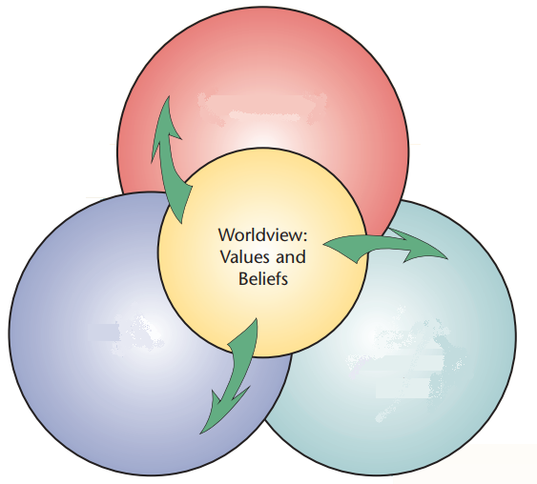
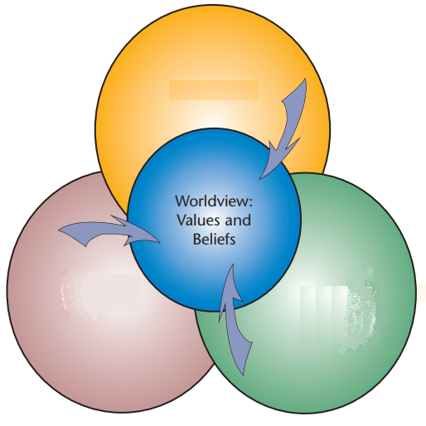
- Use information you learned from our textbook Our Worldview to complete the following diagrams.
- The Crusades
- The Silk Road

- Using the diagram above, give an example of how Renaissance worldview was shaped.

- From the knowledge we’ve gained in class, what is one example of a “Renaissance Idea” that is still a part of the Canadian worldview today?

- Choose one of the following:
- Leonardo of Pisa
- The Black Death

Explain how this person/event/circumstance/route contributed to the start of the Renaissance.
_______________________________________________________
_______________________________________________________
_______________________________________________________
_______________________________________________________
_______________________________________________________
_______________________________________________________
- In the feudal system, what kinds of things would a noble worry about? What kinds of things would a peasant worry about? Who do you think had a more stressful existence? Why?
_______________________________________________________
_______________________________________________________
_______________________________________________________
_______________________________________________________
_______________________________________________________
_______________________________________________________

